**Thermal Modelling Project**

**Introduction:**

The aim of this project is to determine the maximum Junction temperature of 2 Silicon Carbide transistors within a microelectronics assembly (MCM - Multi Chip Module) during operation, at all temperature extremes. It will also be required to show the temperature distribution across the whole of the assembly.

**Multi Chip Module Details:**

This module is based on a High Temperature Co-Fired Ceramic (HTCC) package which is hermetically sealed. The photo below shows a typical HTCC package. The package used in this project will use the same technology, however dimensions, geometry and pin out will be different.

Bottom Kovar Seal Ring & Cavity

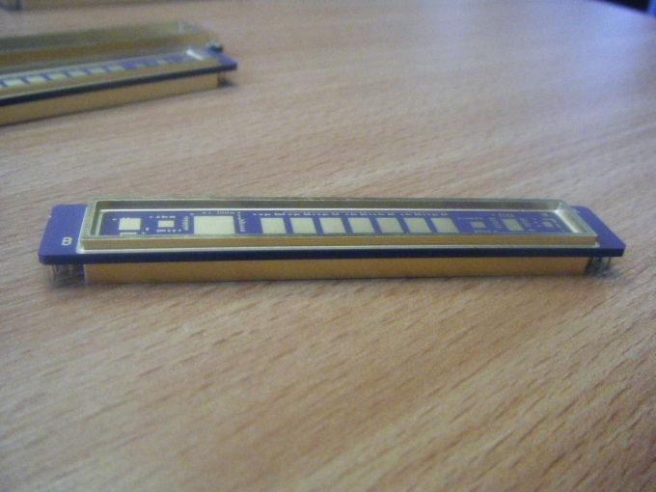

Top Kovar Seal Ring & Cavity

96% Alumina Substrate

The following outline drawings show the dimensions of the package to be modelled as part of this project.



Bottom Cavity



Top Cavity



The above dual cavity package will have formed leads on all 4 sides as shown in this example

The main source of heat with in the package is the 2 SiC MOSFETs as shown in side 2 above, however other components will have some contribution to heat within the package.

* The module will be mounted to a multi-layer copper clad printed circuit board.
* The lead material is Kovar 0.813mm wide, 0.152mm thick, gold over nickel plated.
* The ambient air/cooling air will be -55oC minimum to +85oC maximum.
* Thermal transfer will be by conduction through the formed leads to the PCB and convection to the ambient cooling air.
* Current flow through the 2 MOSFETs will be 7.5 amps continuous.



Circuit Diagram

7.5 amps through this pair of MOSFETs

* The maximum on resistance of each MOSFET is 25 milliohms.
* The power dissipated in each MOSFET will be 1.4 watts (I2R)
* 96% Alumina substrate 2mm thickness
* Top and bottom conductor layer, tungsten, nickel and gold plated.
* 5 Inner tungsten conductor layers.
* All conductor layers approx. 30% of the total ceramic area
* Package leads on a 1.524mm pitch
* Assume leads mounted to an infinite heatsink
* Seal ring top, 3mm high
* Seal ring bottom, 1.5mm high
* All exposed metal surfaces 6um thickness nickel plated, followed by 0.2um gold plate.
* Alternative substrate material – AlN (Aluminium Nitride) – impact on thermal model.